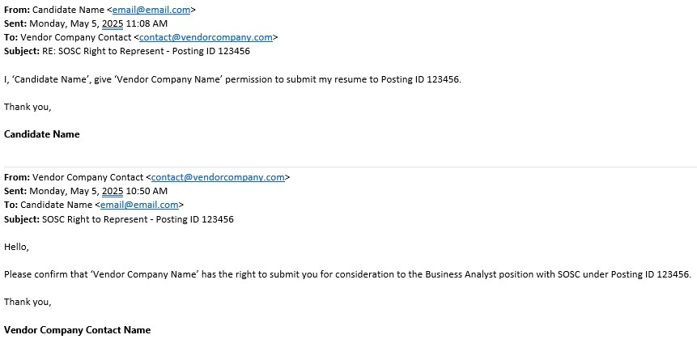

**A ‘Right to Represent’ (RTR)** is a statement from the candidate giving your company permission to represent them for this position. Please note, RTRs are posting specific, and unfortunately, we cannot accept “blanket” RTRs, meaning a RTR must be obtained for each posting to which the candidate is submitted. To be valid, the RTR must be completed from within the timeframe the posting was open to submittals, contain the posting ID number listed, and contain a statement of approval from the candidate giving your company permission to submit. Please attach this document into the candidate’s profile in dotStaff™ at the time of submission.

Process for completing RTR:

1. Send email to Candidate requesting ability to submit

2. Candidate acknowledges request and gives approval to submit for dotStaff™ Posting ID ‘X’

3. Copy and Paste email (showing timestamp and email accounts) into .doc, .docx, or .pdf

4. Title document in the following format, “Posting #XXXXXX”

5. Attach file to Candidate Profile in dotStaff™ VMS Example Statement from Candidate:

“I, John Doe, give ‘Company Name’ the ability to submit my resume to dotStaff™ Posting ID 123456.”